PROJECT REPORT OF CO-OP Project at Industry (Module-2)
ON
Comparative Analysis of RPA Tools for Data Driven Business Process
submitted in partial fulfilment of the requirements for the award of degree of
BACHELOR OF ENGINEERING
In
COMPUTER SCIENCE AND ENGINEERING
Submitted by: Supervised By:
Aaryan Saini Shikha Tuteja
2210990016 Associate Professor, CSE
Chitkara University


DEPARTMENT OF COMPUTER SCIENCE AND ENGINEERING

CHITKARA UNIVERSITY INSTITUTE OF ENGINEERING AND TECHNOLOGY
CHITKARA UNIVERSITY, PUNJAB, INDIA

CONTENTS

S.No. | Title | Page No.
 | Acknowledgement | iv
 | List of Figures and Tables | v
 | Abstract | vi
1 | Introduction | 1-2
2 | Methodology | 2-5
3 | Tools and Technologies | 5
4 | Implementation | 6-9
5 | Major Findings/Outcomes/Output/Results | 10-12
6 | Conclusion and Future Scope | 12
7 | References | 14

DECLARATION

I hereby certify that the work which is being presented in the project report entitle “Comparative Analysis of RPA Tools for Data Driven Business Process” in partial fulfilment of the requirement for the award of the degree of Bachelor of Engineering (Computer Science and Engineering), submitted in the Department of Computer Science and Engineering at Chitkara University Institute of Engineering and Technology, Chitkara University, Punjab, India, is an authentic record of my own work carried out under the supervision of Dr. Shikha Tuteja. The matter presented in this project report has not been submitted in any other university/institute for the award of any degree.

Place: Rajpura (Aaryan Saini)
Date: ……………. (2210990016)

This is to certify that the above statement made by the candidate is correct to the best of my knowledge and belief.

(Shikha Tuteja)
Associate Professor
Department of Computer Science and Engineering
Chitkara University Institute of Engineering and Technology,
Chitkara University, Punjab, India

ACKNOWLEDGEMENT

I would like to express my sincere gratitude to my supervisor, Shikha Tuteja, Associate Professor, Department of Computer Science and Engineering, Chitkara University Institute of Engineering and Technology, for her invaluable guidance, continuous support, and encouragement throughout this project. Her expertise and insights were instrumental in shaping this research.

I am also grateful to the Department of Computer Science and Engineering and the faculty members at Chitkara University Institute of Engineering and Technology for providing the resources and environment necessary to conduct this research.

Finally, I would like to thank my family and friends for their constant motivation and moral support throughout this academic journey.

Aaryan Saini
Roll No. 2210990016
B.E. Computer Science and Engineering
Chitkara University, Punjab, India

LIST OF FIGURES AND TABLES

Figures
Figure 1: Architecture Overview of RPA Platforms
Figure 2: Execution Time Comparison Across RPA Platforms
Figure 3: CPU and Memory Utilization Comparison
Figure 4: Parallel Execution Scalability
Figure 5: Performance Radar Chart
Tables
Table I: Execution Time, Error Rate, and Resource Utilization Across RPA Platforms
Table II: Parallel Execution Results Using Concurrent Bots
Table III: Development Effort and Workflow Complexity Metrics
Table IV: Qualitative Comparison of Integration Capabilities
Table V: Licensing Models and Cost Comparison of RPA Platforms

ABSTRACT

Many organisations are still doing tasks like data entry and report generation manual. These tasks take lot of time also their is chance of human errors. To solve these problems, Robotic Process Automation (RPA) is a good solution. However, selecting the RPA tool is very confusing as different platform provide different features.

In this paper, we will compare the four most used RPA tools UiPath, automation Anywhere, Power platform and Blue Prism. We will do so by running every platform with tasks like data entry, report generation and email handling. In this testing we will compare each platform performance based on execution time and system usage.

Keywords: Robotic Process Automation, UiPath, Automation Anywhere, Blue Prism, Business Process Automation, Comparative Study

1. Introduction
1.1. Background
In recent years, organisations have increasingly started adopting automation technologies to improve efficiency and reduce repetitive manual work performed during daily business operations. Tasks such as data entry, report preparation, invoice processing, and email handling are still carried out manually in many companies, which consumes significant time and also increases the chances of human error. To overcome these issues, Robotic Process Automation has emerged as an important solution for automating repetitive and rule-based business processes [1].
RPA uses software bots that interact with digital systems in a manner similar to human users. Unlike traditional automation approaches, RPA generally works through graphical user interfaces and therefore does not always require deep integration with existing systems. This allows organisations to automate tasks more quickly without making major changes to their infrastructure [2]. Due to these advantages, RPA is now widely adopted across industries such as banking, healthcare, manufacturing, retail, and telecommunications [17].
The global RPA market has grown rapidly in recent years because organisations are increasingly focusing on operational efficiency, cost reduction, and digital transformation initiatives. According to industry reports, the RPA market was valued at approximately US$4.13 billion in 2023 and is expected to grow significantly in the coming years [18]. Several major platforms currently dominate the market, including UiPath, Automation Anywhere, Blue Prism, and Microsoft Power Automate. Each of these platforms provides different capabilities related to workflow automation, scalability, cloud deployment, AI integration, and enterprise management [3], [30]. However, despite their popularity, organisations often face difficulty in selecting the most suitable platform according to their operational requirements.
1.2. Problem Statement
Although many RPA platforms are available today, selecting the appropriate automation tool remains a challenging task for organisations. Most existing studies and industry comparisons mainly focus on feature descriptions and vendor-provided specifications instead of conducting detailed practical performance evaluations [36]. Because of this, there is limited experimental evidence regarding how different RPA tools perform under similar business automation conditions.
Another major issue is the lack of a standard benchmarking framework for comparing RPA platforms. Important factors such as execution speed, CPU and memory utilization, scalability, integration capability, and workflow development effort are often evaluated separately rather than together in a controlled environment [37]. As a result, organisations may struggle to determine which platform best fits their specific business needs.
In addition, rapid advancements in intelligent automation and AI-enabled RPA have increased the complexity of platform selection further. Organisations now require solutions that not only automate repetitive tasks but also support scalability, flexibility, and integration with modern enterprise systems [7]. Therefore, a structured comparative analysis based on practical experimentation is necessary to provide clearer understanding of the strengths and limitations of major RPA platforms.

1.3. Objectives
- To compare the performance of major RPA platforms including UiPath, Automation Anywhere, Blue Prism, and Microsoft Power Automate.
- To evaluate execution time, error rate, CPU usage, memory consumption, and throughput during automation tasks.
- To analyse development effort and workflow complexity across different RPA platforms.
- To study scalability using parallel bot execution scenarios.
- To examine integration capabilities, usability, and enterprise readiness of each platform.
- To provide practical guidance for organisations in selecting suitable RPA tools according to business requirements.

1.4. Scope and Limitations
This study focuses on the comparative evaluation of four widely used RPA platforms using controlled experimental conditions. The analysis is limited to three benchmark tasks: data entry automation, report generation, and email processing. All experiments were performed on the same hardware and software configuration to maintain consistency during testing.
The datasets used during implementation were artificially created to simulate realistic business environments while avoiding privacy and confidentiality concerns. The study mainly evaluates technical and performance-related characteristics of the platforms and does not include organisational aspects such as employee training requirements, vendor support quality, or long-term operational maintenance.
In addition, the results are dependent on the specific versions of the platforms used during experimentation. Since RPA technologies continue to evolve rapidly, future platform updates may produce different outcomes. The experiments were also conducted in a single-machine environment, which may not completely represent large-scale enterprise deployment conditions [38].

2. Methodology
2.1 Experimental Setup
To ensure fair comparison among the selected RPA platforms, all experiments were performed under the same controlled environment. The testing system was configured with Windows 10 (64-bit), Intel Core i7 processor, 16 GB RAM, and SSD storage. The same hardware configuration was maintained throughout the experiments to avoid variations in performance results caused by system differences.
The study included four major RPA platforms: UiPath, Automation Anywhere, Blue Prism, and Microsoft Power Automate. The versions used during experimentation were UiPath Studio 2025.10, Automation Anywhere Automation 360 v23.1, Blue Prism v7.1, and Microsoft Power Automate Desktop with cloud flow integration.
Before testing each platform, the system was restarted to reduce the impact of background processes, cached memory, and residual application activity. This helped maintain consistency and improve the reliability of benchmarking results.

2.2Benchmark Task Design
To evaluate the practical capabilities of the RPA platforms, three common business automation tasks were selected. These tasks were chosen because they represent routine data-driven processes frequently automated in real organisational environments [35].
• Data Entry Automation: A CSV dataset containing 100 structured records was prepared. The automation workflow was required to read the CSV file and transfer the data into Microsoft Excel sheets. This task mainly evaluated structured data processing capability and interface automation efficiency.
• Report Generation: The second benchmark focused on automated report creation using sales-related datasets. The workflows calculated totals, generated summary statistics, and created formatted reports with charts and tables. This task helped evaluate data processing performance, reporting capability, and document automation support.
• Email Processing: The third task involved automated email handling. Emails with attachments were processed, important order-related information was extracted, and the extracted data was stored into a database. This task evaluated email integration capability, semi-structured data handling, and workflow coordination.
All datasets used during experimentation were artificially created to maintain consistency across platforms and avoid confidentiality or privacy-related concerns.

2.3. Performance Metrics
The comparative evaluation was based on both quantitative and qualitative metrics. The following performance indicators were measured during workflow execution:
Performance Metrics
• Execution Time: Total time required to complete a process, averaged across five runs.
• Error Rate: Percentage of records resulting in exceptions during execution.
• CPU Utilization: Peak and average CPU consumption recorded during workflow execution.
• Memory Utilization: Peak working memory usage measured in megabytes (MB).
• Throughput: Number of records processed per minute.
Development and Usability Metrics
• Development Effort: Total person-hours required to implement workflows.
• Workflow Complexity: Number of activities, steps, or reusable objects involved in implementation.
• Recorder Effectiveness: Practical effectiveness of built-in recording and automation support tools.
These metrics were selected because previous studies often focus mainly on feature comparison rather than measurable operational performance [36], [37].

2.4Workflow Development and Testing Protocol
All workflows were developed by the same individual to maintain consistency during implementation. Standard automation practices such as logging, exception handling, and resource management were applied across all platforms.
Each benchmark task was executed five times on every platform. Resource utilization and execution behaviour were monitored during every run. No significant outliers were observed in the collected data.
Parallel execution testing was also performed using two concurrent bots for the data entry process. This experiment was included to evaluate scalability and enterprise-readiness of the selected RPA platforms.
2.5. Platform Implementation
A. UiPath Implementation
The workflows for UiPath were developed using UiPath Studio, while Orchestrator was used for scheduling and monitoring execution. Built-in activities supported CSV handling, Excel automation, PDF report generation, and IMAP-based email processing. Parallel execution was managed through multiple robots coordinated by Orchestrator.
B. Automation Anywhere Implementation
Automation Anywhere Automation 360 was deployed using a cloud-based setup. Bot Creator was used for workflow development and Control Room managed execution monitoring. Built-in packages supported CSV processing, Excel automation, and email integration. IQ Bot was additionally used for handling semi-structured attachments.
C. Blue Prism Implementation
Blue Prism workflows were implemented using Process Studio and reusable Visual Business Objects (VBOs). Separate VBOs were developed for Excel operations, file handling, and email processing. Work queues were configured for task allocation and controlled execution management.
D. Microsoft Power Automate Implementation
Power Automate used both desktop flows and cloud flows during experimentation. Desktop flows handled UI-based automation tasks, while cloud flows managed Outlook email integration and database connectivity using HTTP requests and Microsoft 365 services.
2.6. Scalability Evaluation
Scalability testing was performed using concurrent bot execution scenarios. Two bots were configured simultaneously for the data entry task, and performance improvements were measured by comparing execution time between single-bot and dual-bot execution.
This evaluation helped analyse how efficiently each platform handles increased workload and distributed automation environments, which is an important requirement for enterprise-scale RPA deployment [24].

3. Tools and Technologies
3.1 Programming Languages and Platforms
The implementation and evaluation of the automation workflows were carried out using different RPA platforms including UiPath, Automation Anywhere, Blue Prism, and Microsoft Power Automate. The experiments were performed on a Windows 10 (64-bit) environment with Intel Core i7 processor and 16 GB RAM.
The workflows involved CSV processing, Excel automation, email handling, report generation, and database integration tasks.

3.2 Tools and Frameworks
• UiPath Studio — Workflow development and automation design.
• Automation Anywhere Automation 360 — Cloud-based bot development and execution management.
• Blue Prism Process Studio — Enterprise automation workflow and Visual Business Object development.
• Microsoft Power Automate — Desktop and cloud flow automation.
• Microsoft Excel — Structured data storage and reporting.
• IMAP/SMTP Services — Email processing and automation tasks.
• SQL Database Connectors — Data storage and integration support.

3.3 Development Environment
The workflows were implemented and tested under controlled conditions using the same hardware configuration for all platforms. Logging, exception handling, and workflow monitoring tools provided by each platform were used during execution analysis.

4. Implementation
4.1 System Architecture
The implementation of the study was carried out using four major RPA platforms: UiPath, Automation Anywhere, Blue Prism, and Microsoft Power Automate. The workflows were designed to automate common business-related processes including data entry, report generation, and email processing.
The architecture mainly consisted of structured input datasets, automation workflows, execution monitoring modules, and output systems such as Excel sheets, PDF reports, and databases. Each platform processed the same tasks under controlled conditions so that performance comparison could remain fair and consistent. The implementation approach involved workflow creation, execution monitoring, report generation, and performance evaluation across all selected RPA platforms.
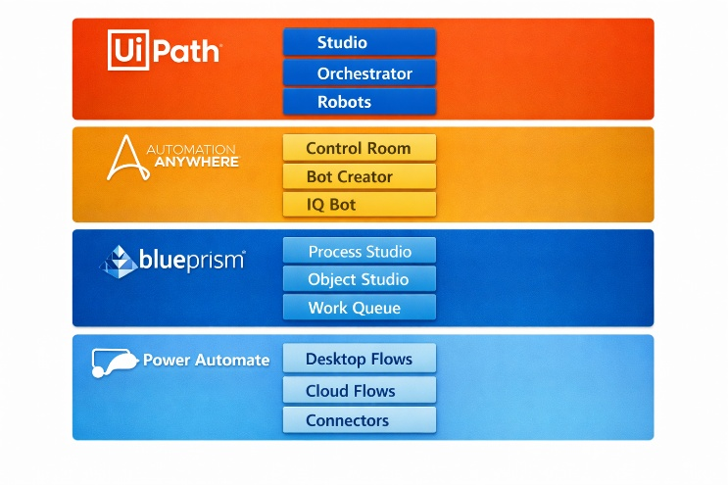
Fig. 1: Architecture Overview of RPA Platforms

4.2 Workflow Execution and Benchmark Tasks
Three benchmark automation tasks were implemented on all four platforms. The first task focused on structured data entry where CSV records were automatically transferred into Excel sheets. The second task involved automated report generation using sales-related datasets, while the third task handled automated email processing and extraction of important information from attachments.
Each workflow was executed five times to measure execution consistency and system performance. Metrics such as execution time, throughput, CPU utilization, and memory consumption were recorded during every run.
A. UiPath Implementation
The UiPath workflows were developed using UiPath Studio 2025.10, while Orchestrator was used for scheduling jobs and monitoring execution. Several built-in activities were used during implementation, including CSV reading, Excel automation, PDF report generation, and IMAP-based email retrieval. UiPath provided strong native support for these automation tasks, which reduced development complexity and implementation time.
For scalability testing, parallel execution was configured using two robots managed through Orchestrator. The dataset was divided between the robots so that both executions could run simultaneously. This setup helped evaluate how efficiently UiPath handles concurrent execution in enterprise-scale automation scenarios.
B. Automation Anywhere Implementation
Automation Anywhere Automation 360 v23.1 was deployed using a cloud-based environment. Bot Creator was used for workflow development, while Control Room handled bot execution, scheduling, and monitoring. Built-in commands supported CSV processing, and additional packages were used for Excel operations, PDF generation, and email automation.
IQ Bot was also used in selected scenarios involving semi-structured attachments. This improved extraction accuracy in cases where input formats were inconsistent or partially unstructured, which is often challenging in practical automation environments.
C. Blue Prism Implementation
Blue Prism v7.1 was configured in a single-machine environment using Process Studio. Visual Business Objects (VBOs) were developed for Excel handling, email processing, and file system operations. A work queue was created to distribute tasks to the robot in a controlled and manageable manner.
Exception handling and recovery stages were implemented throughout the workflows to improve execution reliability. Runtime monitoring of the work queue was also performed because Blue Prism heavily depends on stable queue management for enterprise automation processes.
D. Microsoft Power Automate Implementation
Power Automate used a combination of desktop flows and cloud flows during implementation. Desktop flows mainly handled user interface automation tasks such as Excel interaction and data extraction, while cloud flows managed Outlook email processing and database integration through HTTP requests and Microsoft 365 services.
The integration with Microsoft services made Power Automate particularly suitable for workflows operating inside Microsoft-based enterprise environments.

5. Major Findings / Outcomes / Output / Results
5.1. Model Performance Metrics
Table I presents execution time, error rate, and resource utilization measurements for each platform across benchmark tasks. Values represent means over five runs
.
Platform | Task | Time (s) | Error Rate | CPU (%) | Memory (MB) | Throughput (rec/min)
UiPath | Data Entry | 12.3 | 0.0% | 45 | 352 | 488
 | Report Gen | 20.1 | 0.0% | 50 | 398 | 149
 | Email Proc | 18.7 | 0.0% | 42 | 335 | 32
Automation Anywhere | Data Entry | 15.2 | 0.0% | 50 | 368 | 395
 | Report Gen | 24.8 | 0.0% | 55 | 422 | 121
 | Email Proc | 22.3 | 0.0% | 48 | 388 | 27
Blue Prism | Data Entry | 18.1 | 0.0% | 35 | 302 | 332
 | Report Gen | 28.3 | 0.0% | 40 | 348 | 106
 | Email Proc | 25.6 | 0.0% | 38 | 315 | 23
Power Automate | Data Entry | 20.4 | 0.0% | 62 | 452 | 294
 | Report Gen | 30.6 | 0.0% | 68 | 485 | 98
 | Email Proc | 27.8 | 0.0% | 58 | 428 | 22

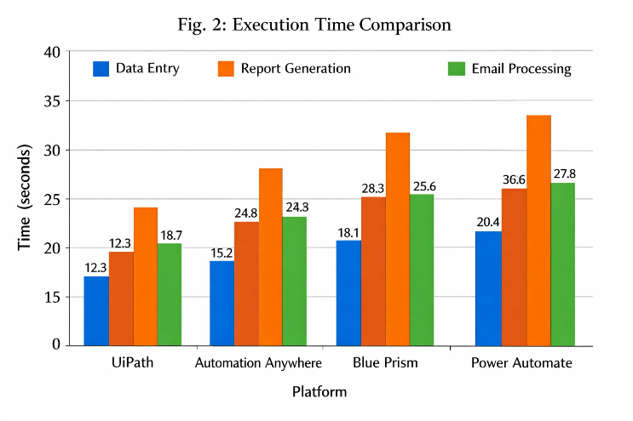
Fig. 2: Execution Time Comparison Across RPA Platforms
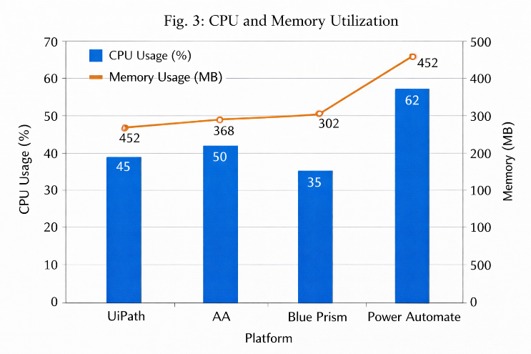
Fig. 3: CPU and Memory Utilization Comparison
Table II presents the results of parallel execution testing for the data entry task using two concurrent bots:
Platform | Single (s) | Dual (s) | Gain (%)
UiPath | 12.3 | 9.8 | 20.3
Automation Anywhere | 15.2 | 11.5 | 24.3
Blue Prism | 18.1 | 13.2 | 27.1
Power Automate | 20.4 | 16.8 | 17.6

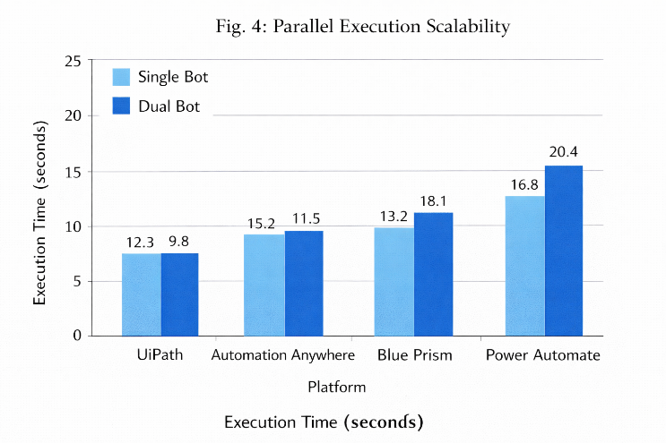
Fig. 4: Parallel Execution Scalability

Table III summarizes development metrics across platforms:
Platform | Data Entry (hr) | Report Gen (hr) | Email Proc (hr) | Total (hr) | Total Activities/Steps
UiPath | 1.5 | 1.7 | 1.8 | 5.0 | 187
Automation Anywhere | 2.0 | 2.2 | 2.1 | 6.3 | 156
Blue Prism | 3.0 | 3.2 | 3.5 | 9.7 | 142
Power Automate | 1.8 | 2.0 | 2.5 | 6.3 | 168

Table IV provides qualitative assessment of integration capabilities:
Capability | UiPath | Automation Anywhere | Blue Prism | Power Automate
REST API | Native | Native | VBO required | Native (HTTP)
Database Connectors | Extensive | Extensive | VBO required | Limited (SQL)
Email (IMAP/SMTP) | Native | Native | Native (VBO) | Native (Outlook)
SAP Integration | Premium | Premium | Native | Limited
Custom .NET Libraries | Native | Via API | Via COM | Via API
RPA Recorders | 5 types | 3 types | None | Limited

6 Discussion
6.1 Performance Trade-offs
The results point to pretty obvious performance gaps between the platforms, and most of that seems to come from how each one is built and how it runs tasks.
UiPath was clearly the fastest in every task tested. In the data entry task, for instance, it finished in 12.3 seconds, while the others took from 15.2 to 20.4 seconds. That is not a small difference. It shows UiPath likely has a more efficient execution engine and stronger task handling overall. Looking at the full set of results, it stayed about 20–40% faster than the competing platforms, which is hard to ignore.
Blue Prism, meanwhile, stood out more for resource efficiency than raw speed. Its CPU usage stayed around 35–40%, and memory use ranged from 302 to 348 MB, both lower than the others. That sounds good, though the trade-off is pretty clear: it ran about 40–50% slower than UiPath. To me, that makes Blue Prism feel more focused on stability and careful resource control than on finishing tasks quickly.
Power Automate used the most resources, with CPU at 58–68% and memory at 428–485 MB. That probably connects to its desktop automation model. Even then, for companies already deep in Microsoft tools, that cost may still be worth it.
6.2 Development Productivity Implications
Development time differed a lot across the platforms, landing somewhere between about 5 and 9.7 hours. That gap matters more than it first seems, since it has a direct effect on implementation cost and also how fast a solution can actually go-live.
UiPath took the least effort to build in. Honestly, that makes sense because its interface is easier to work with, the recording options are practical, and the activity library is broad enough to save time. Blue Prism, on the other hand, needed more time. Its method is more rigid, with objects and processes defined first before anything really moves. That slows the start, definitely, though it usually pays off later through better maintainability and reuse.
6.3 Scalability and Enterprise Readiness
For scalability and enterprise use, all four platforms can handle heavier workloads with parallel execution, though they do it differently. Blue Prism stands out most to me because its work queue model is strong, especially when tasks need clear priority and failures have to be managed properly. Automation Anywhere depends more on cloud architecture for flexibility, while UiPath uses Orchestrator effectively. Power Automate grows through Microsoft’s cloud setup..
6.4 Cost-Effectiveness Framework
Licensing models vary significantly across platforms.
Table V summarizes approximate costs and considerations.
Platform | Model | Cost (Approx.) | Notes
UiPath | User/Bot | $15k–25k/bot | Extra AI cost
Automation Anywhere | Cloud | $9k–18k/bot | IQ Bot included
Blue Prism | Digital Worker | $12k–18k/worker | Extra add-ons
Power Automate | User/Flow | $40/user/month | Unlimited flows

The most suitable option depends on usage requirements. For occasional or small-scale automation, Power Automate may be more cost-effective. However, for continuous, large-scale automation, enterprise platforms with subscription-based models may provide better value.
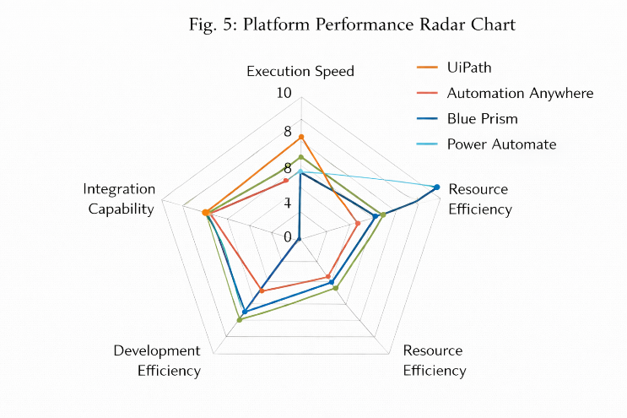
Fig.5:PerformanceRadarChart
7. Conclusion and Future Work
A. Summary of Findings
This study compares different RPA platforms for data-driven business tasks using a structured approach. It evaluates multiple factors, not only execution speed but also system resource usage, development effort, and scalability.
The results highlight noticeable differences between the platforms. UiPath performed consistently well across almost all tasks, including data entry, report generation, and email processing. In many cases, it was around 20–40% faster than the others, while maintaining moderate CPU and memory usage. This balance between performance and efficiency makes UiPath a strong option.
Blue Prism, on the other hand, showed better resource efficiency. It generally consumed less CPU and memory compared to the other platforms, which makes it suitable for environments where stability and predictable performance are more important than speed. However, its execution time was usually higher.
Power Automate appeared to be a practical choice for organizations already using the Microsoft ecosystem. Its built-in integrations and relatively lower cost make it suitable for small to medium-scale automation tasks.
Development effort also varied significantly. UiPath required less development time due to its more user-friendly design, whereas Blue Prism took longer because of its structured approach. At the same time, this structure can be beneficial for long-term maintenance and governance. All platforms supported parallel execution, which improved performance by approximately 18–27%, although each platform handled scaling differently.
B. Selection Guidance
Based on these findings, we recommend:
Context | Platform | Rationale (Short)
High-volume | UiPath | Fast execution, strong AI
Regulated | Blue Prism | Strong security, audit support
Document-heavy | Automation Anywhere | IQ Bot, handles unstructured data
Microsoft-based | Power Automate | Office 365 integration, low cost
Mixed systems | UiPath / Automation Anywhere | Wide connectors, flexible deployment

C. Future Research Directions
The biggest one, in my view, is stronger integration of artificial intelligence, especially machine learning, natural language processing, and computer vision. Those areas matter because unstructured data is still a stubborn problem in many automation settings, and current approaches often do not deal with it very well.
Cost evaluation also needs a more serious treatment. A useful cost model should not stop at licensing fees. It has to include infrastructure, development effort, and long-term maintenance too. Looking only at the starting price gives a narrow picture, and honestly, that can push people toward conclusions that are too simple.
Another issue that deserves more attention is the multi-platform environment. Many organizations use more than one RPA tool at once. That is normal in practice, yet a lot of research keeps judging platforms one by one, which feels disconnected from how companies actually work.
Long-term maintainability should be examined much more closely as well. System updates, technical debt, and changes in performance over time can quietly create major problems, though they are often treated like side issues.
8. References
[1] D. Agrawal and K. R. Varalakshmi, “Transforming RPA in Science & Commerce: A Systematic Mapping Study,” in Proc. 1st Int. Conf. Innovative Sustainable Technologies for Energy, Mechatronics and Smart Systems, Dehradun, India, 2024.
[2] B. Axmann, S. A. Dzhelil, and A. Najeeb, “Practical Comparison of UiPath and Power Automate by Creating an Automation Use Case from Logistics,” in Proc. 14th Int. Conf. Advanced Computer Information Technologies, Czech Republic, 2024.
[3] S. Khan, “Comparative Analysis of RPA Tools – UiPath, Automation Anywhere & Blue Prism,” International Journal of Computer Science and Mobile Applications.
[4] G2, “Grid Report for Robotic Process Automation (RPA) – Winter 2025.”
[5] S. M. M. Rahman, “Enhancing Pega Robotics Process Automation with Machine Learning,” in IEEE Int. Conf. Computing and Applications, Kuala Lumpur, 2024.
[6] Artificio Products, “AI Agents Outperform RPA by 40% in Unstructured Document Processing,” ERP Today.
[7] L. Patrício, L. Varela, and Z. Silveira, “Integration of Artificial Intelligence and Robotic Process Automation,” Applied Sciences.
[8] L. Patrício, L. Varela, and Z. Silveira, “Framework for Integrating Requirements Engineering and DevOps Practices in RPA,” Applied Sciences.
[9] J. Wewerka, C. Micus, and M. Reichert, “Seven Guidelines for Designing the User Interface in RPA,” in IEEE Conf. Business Informatics, 2021.
[10] R. Hussain, “UiPath vs. Blue Prism: Which’s the Superior RPA Tool?” Royal Cyber Blog.
[11] G. Verma, “Blue Prism vs UiPath: The Honest Enterprise RPA Comparison,” Kanerika Blog.
[12] A. Hrytsak, “RPA Tools: A Detailed Comparison of Top Automation Platforms,” Eleks Blog.
[13] R. Syed and M. Wynn, “How to Trust a Bot: An RPA User Perspective,” in Int. Conf. Business Process Management, 2020.
[14] L. Patrício et al., “Implementation of RPA Based on a Multi-Objective Mathematical Model,” Sustainability.
[15] A. Schlegel and M. S. A. Khan, “Business Process Automation Projects in RPA Context,” Business Process Management Journal.
[16] Gartner Inc., “Magic Quadrant for Robotic Process Automation.”
[17] W. M. P. Van der Aalst et al., “Robotic Process Automation,” Business & Information Systems Engineering.
[18] MarketsandMarkets, “Robotic Process Automation Market – Global Forecast to 2032.”
[19] L. Willcocks, M. Lacity, and A. Craig, “Robotic Process Automation: Strategic Transformation Lever.”
[20] I. Ribeiro, R. Lima, and T. S. Oliveira, “RPA Adoption: A Systematic Literature Review,” Procedia Computer Science.
[21] A. Syed et al., “Robotic Process Automation: Contemporary Challenges,” Computers in Industry.
[22] T. T. H. Le et al., “A Systematic Literature Review of RPA,” Journal of Information Technology Management.
[23] A. Asatiani and E. Penttinen, “Turning RPA into Commercial Success,” Journal of Information Technology Teaching Cases.
[24] M. Lacity et al., “Robotic Process Automation at Telefónica O2.”
[25] Microsoft Corporation, “Microsoft Acquires Softomotive,” Microsoft News Center.
[26] C. A. D. Santos and G. S. Lima, “RPA and Business Process Management,” IEEE Latin America Transactions.
[27] S. Madakam et al., “The Future Digital Workforce: RPA,” Journal of Information Systems and Technology Management.
[28] UiPath Inc., “UiPath Recognized as a Leader in Gartner Magic Quadrant 2024.”
[29] SS&C Technologies, “Blue Prism Recognized as a Gartner Leader.”
[30] J. Page, “Power Automate vs UiPath vs Blue Prism,” ApiX-Drive Blog.
[31] Bacancy Technology, “UiPath vs Automation Anywhere vs Blue Prism,” Bacancy Blog.
[32] AutomationEdge, “Top RPA Tools: The Ultimate Guide 2026.”
[33] Global Solutions Enterprise, “Comparison of RPA Platforms in Practice.”
[34] Forrester Research, “The Forrester Wave: RPA, Q1 2024.”
[35] D. Kumar et al., “Impact of RPA on Business Processes,” Supply Chain Forum.
[36] P. Hofmann et al., “RPA: A Taxonomy of Current Research,” ICIS.
[37] T. Almutairi and R. Alharbi, “Comparative Study of RPA Tools,” IJACSA.
[38] M. Schmitz et al., “RPA: Current Practices and Future Directions,” Journal of Emerging Technologies in Accounting.
[39] C. B. et al., “Framework for Evaluating RPA Projects,” Procedia Computer Science.

